2023 Outdoor Water Ban 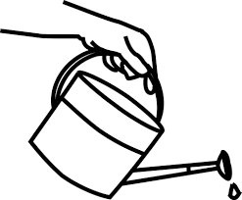

Due to the drought-like weather we have been experiencing and the increased use of community members using irrigation systems, the City of Montgomery has lower than normal water levels, so the City has issued a watering ban.
Watering and irrigation of lawns and washing of vehicles – cars, motorcycles, side-by-sides, ATV’s, Golf Carts, etc. – will be on an “odd/even” schedule. Homes with an odd number address will be permitted to water, irrigate, or wash vehicles on odd numbered days and homes with an even number address on even numbered days.
Watering, irrigation, or washing of vehicles will not be allowed any day between the hours of 12:00 p.m. [noon] and 6:00 p.m. Watering, irrigation, or washing of vehicles on the assigned day may be done between the hours of 6:00 p.m. and 11:00 a.m. Hand watering of flowers, gardens, and landscaping will be permitted. Pool filling – both wading and swimming – will be permitted. Water toys and sprinklers for children actively playing are also permitted.
The City of Montgomery appreciates your cooperation. We need to work together to keep our community safe! For Questions, please call the city office at (507) 364.8888.

